


FOCUSATH

QUICK START

GUIDE

Quick Start Guide

Overview of the Guide
This is a Quick Start Guide for the Android application, Focusath, the primary research instrument for my 4th year Undergraduate Honours Project. The intention of this document is to guide you through the installation process, and the general flow of the application, as well as common issues you may face with the app.

Overview of the app
This section provides a brief overview of the app, including its purpose and functionality.

Purpose of the app, and your involvement
This app is my primary research instrument core component of my 4th year Undergraduate Honours Project / Dissertation. The idea of the app is to integrate psychological concepts derived from Reality Therapy, alongside usage tracking technologies to help address smartphone and social media addiction. Your involvement with the app is with assisting with gathering data for myself to then evaluate. Part of my dissertation involves gathering data from participants, and evaluating if that data meets the project hypothesis.

How the app works, and what you’ll be doing
You will be making use of the app for a period of three weeks, and each week, beginning from when you install the app and finish the onboarding process (see Section III. for more information), you will send an email that contains your app usage data for the week. This will be the data used in the evaluation section of my dissertation.

Ill. Installation & Getting Started
This section covers the steps needed to install the app.

Installation
To install the application, follow these steps:
- Download the .apk file sent to you via email.
- Navigate to where the file was downloaded: This can typically be found by opening the files app and navigating to the downloads folder.
- Install the app by double tapping the .apk file.
If this did not work, follow these next steps:
4a. When prompted, go to the settings app and provide permission to “Install unknown apps”: If you are prompted with more instructions, follow those instructions. After this, attempt to reinstall the app
4b. If step 4a didn’t work, enable developer mode by going to Settings About Phone, and tapping the Build Number (sometimes labelled Version Number) 5-7 times until a pop up appears. The specifics may vary depending on the phone model and Android version, look up instructions for your phone and/or Android version for further help. Afterwards, try reinstalling the app again.
These instructions are just a general overview of how to install the app, specific parts may be different depending on your phone, please contact myself via Email if you require assistance installing the app.

Onboarding process
Opening the app for the first time will present you with the onboarding process. This provides brief information about the app, it’s purpose, and your involvement (similar to the contents of this document).
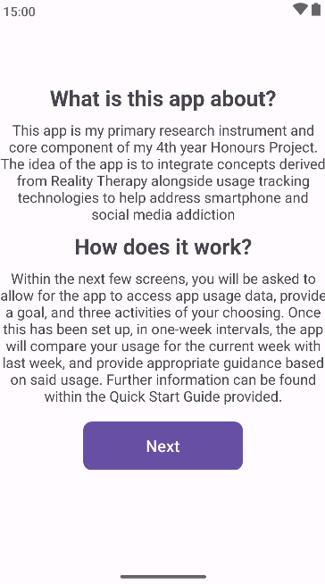
Figure 1.1 – One of the onboarding screens
Once you have read through all the information provided, you will then be asked to come up with and type in a goal that’s completion you think is being delayed by your current app / phone usage.
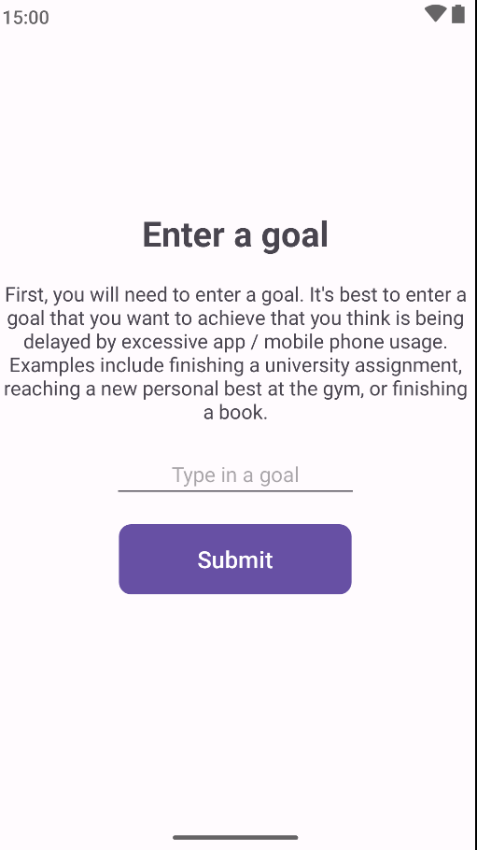
Figure 1.2 – The goal entry screen
Afterwards, you will be asked to provides three of your favourite activities that you can replace your phone usage with.
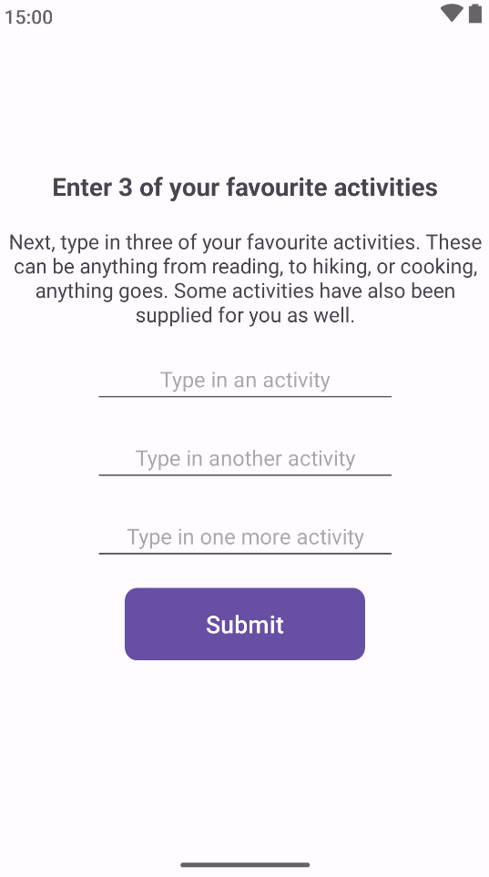
Figure 1.3 – The activity entry screen
To finish the onboarding process, you will be given a recommendation to enable notifications for the app, though as explained in the app, this is completely optional. You will also be asked to compose an email with your current usage stats
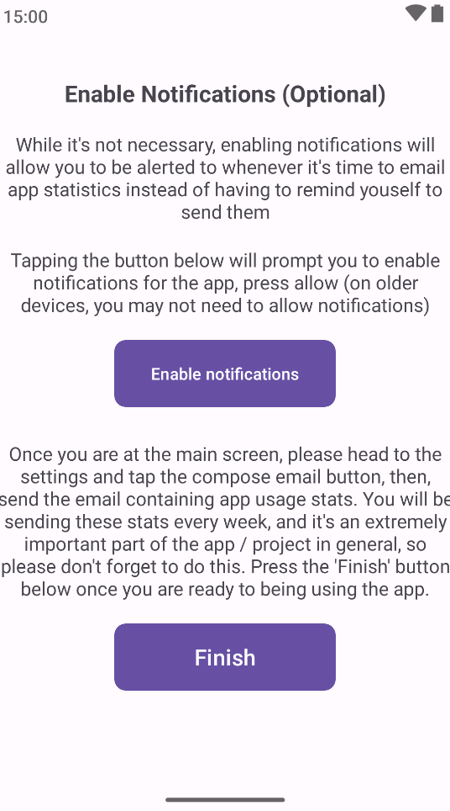
Figure 1.4 – Screen asking user to enable notifications

Normal application experience
Once you have finished the onboarding, you will be taken to the main screen, here, you’ll be able to view your usage stats.
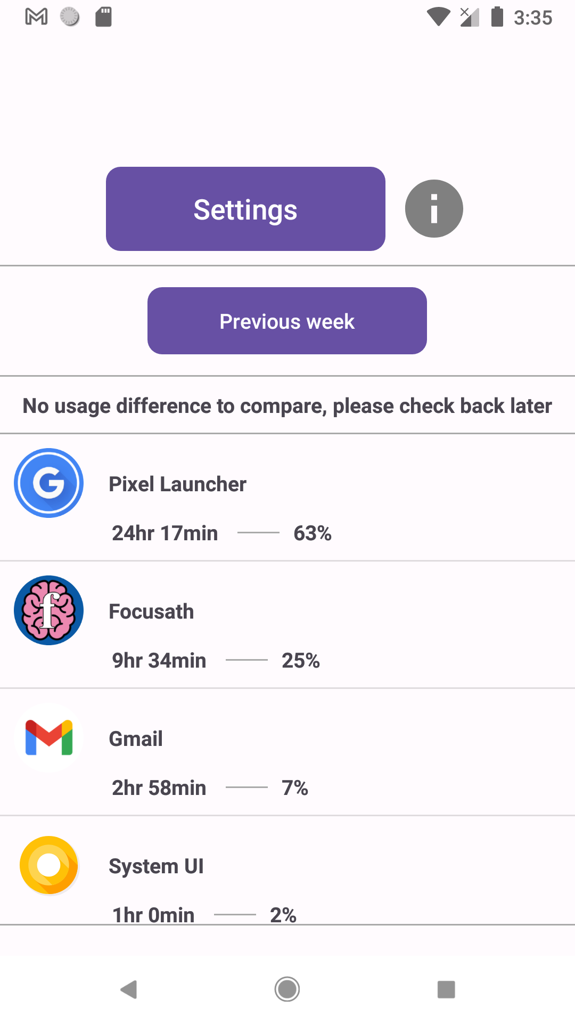
Figure 1.5 – Main screen user will interact with
The settings screen is where you will be able to compose an email containing your usage stats, and also change your current goal or activities.
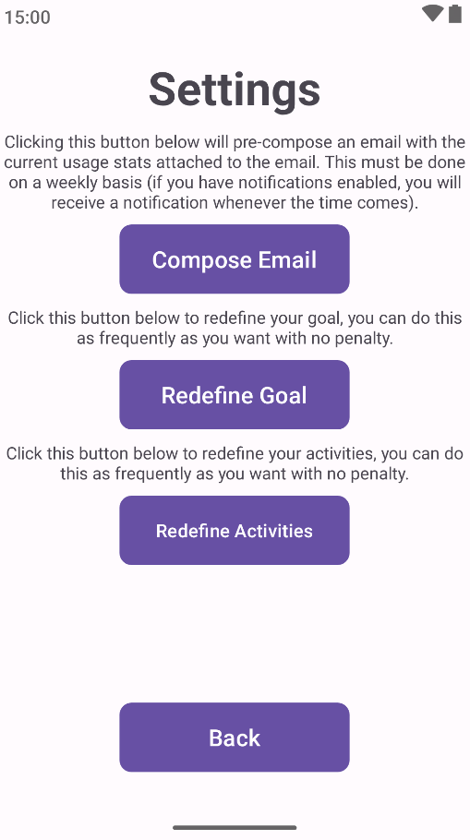
Figure 1.6 – Settings screen
Once a week has passed, when you open the app, you will be presented with one of two screens depending on how your usage has been over the last week.
If your usage has lowered, you will be presented with a screen appraising your (lack-of) usage, alongside your current goal.
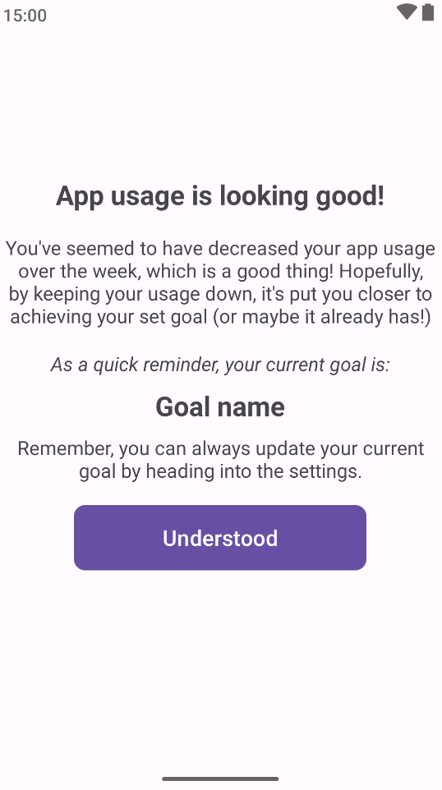
Figure 1.7 – Screen appraising user for their lowered usage
If it has gone up, you will be presented with a different screen, asking you to evaluate your usage, and ask if you want to change your current goal.
After returning from changing your goal, or not changing your goal at all, you will be provided a list of your own activities and pre-set activities, alongside the app encouraging you to lower your usage for the week.
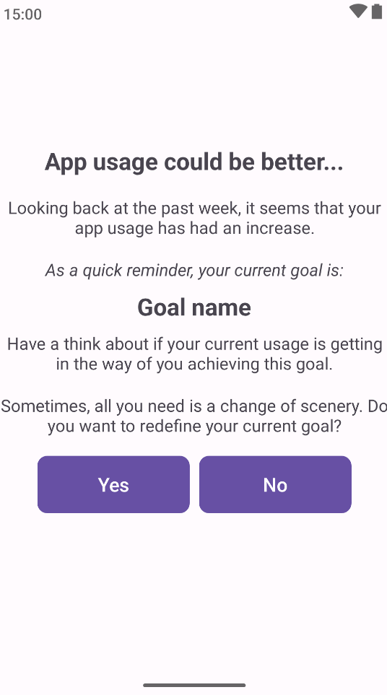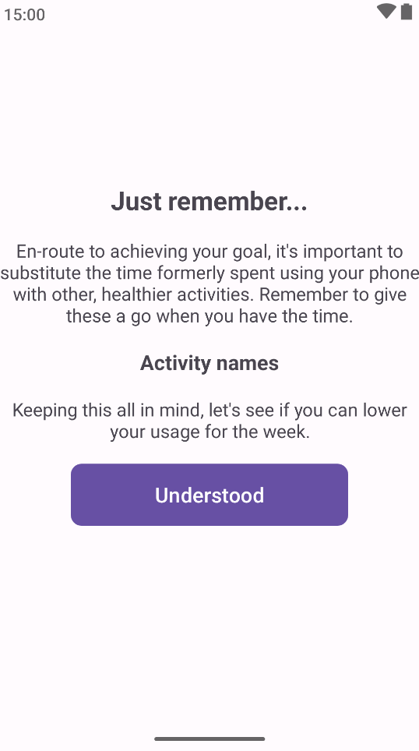
Figures 1.8 & 1.9 – Screens asking the user to evaluate their usage
Once back on the main screen, now that usage data for the previous week is available, the user can now see their usage for the previous week on a separate screen by tapping the “Previous week” button.
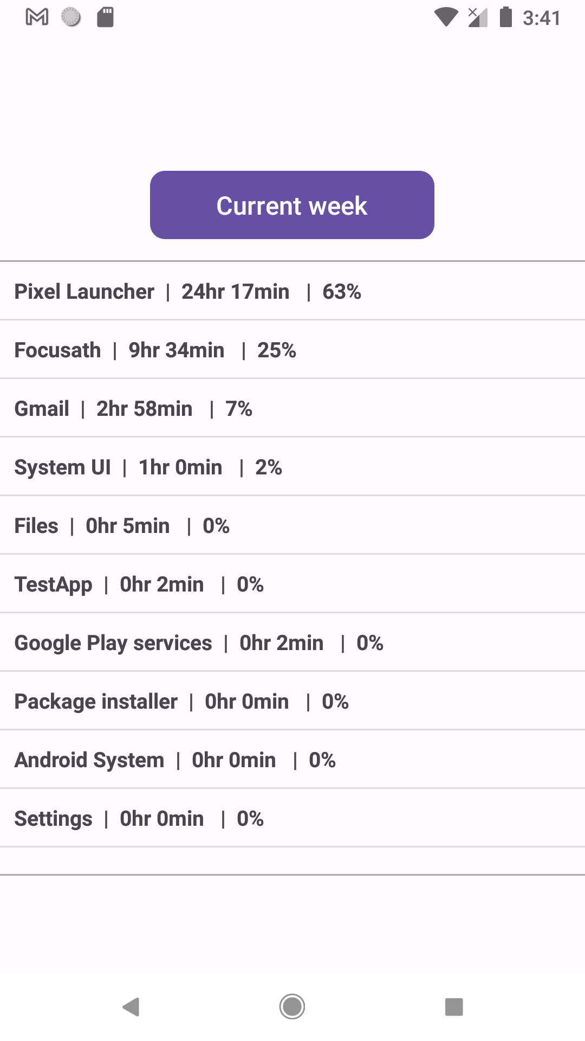
Figure 1.10 – Previous week of usage stats available to view

IV. Troubleshooting
Common Issues and Solutions
“I wasn’t sent the notification for the weekly check” – Ensure that you allowed notifications during the onboarding process, if this is the case, note down the date and time of when you installed the app, and check back with the app in week intervals from that point.
“I can’t install the application” – Double check you followed the instructions as presented in Section II. The instructions may differ depending on your specific phone or Android version.
“The app usage increase reading is inaccurate” – For the first week, this will be the case, due to how Android queries usage stats if done in the middle of a week. After a week of having the app installed, and after your first weekly check, this should adjust to have an accurate reading.
“I can’t access my previous usage” – This will be the case for the first week, since a week hasn’t passed. After a week, your usage for the previous week will be available to view.
“My app usage stats have changed before the weekly check in” – This, similar to how usage readings can be inaccurate, is due to a technical limitation of how Android lets developers query usage data (see https://developer.android.com/reference/android/app/usage/UsageStatsManager for more information). Your usage readings should correct itself by next week.
“The activity suggestions gave two of the same suggestion” – This is because suggestions bundled with the app are randomly picked from a list.

If you encounter any bugs or issues, need further assistance with using the app, or have any general inquiries about your participation, please contact me via email at ldebuf300@caledonian.ac.uk and I will attempt to respond to you as quick as possible

Thank you for choosing to, and taking time to participate in using the application.
-Liam

